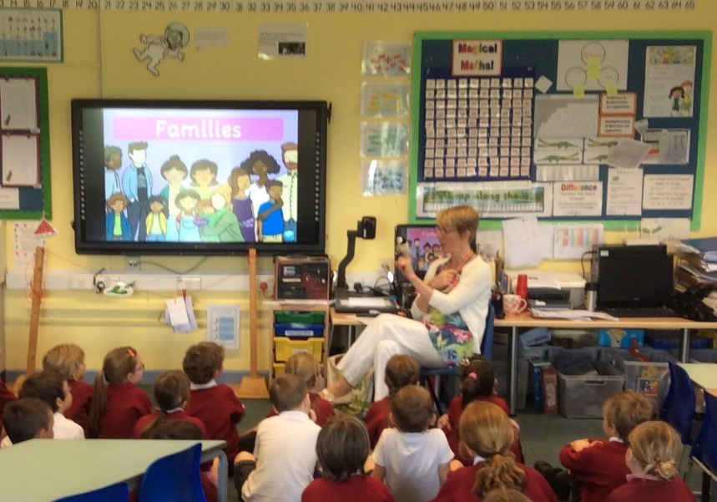
SPACE Youth Project

Mel Lane: experienced KS1 and KS2 Teacher www.spaceyouthproject.co.uk
Teacher Trainer and Professional Development Lead education@spaceyouthproject.co.uk
01202 205279
Staff Training
Staff Training (for any staff and Governors) (1 hour+)

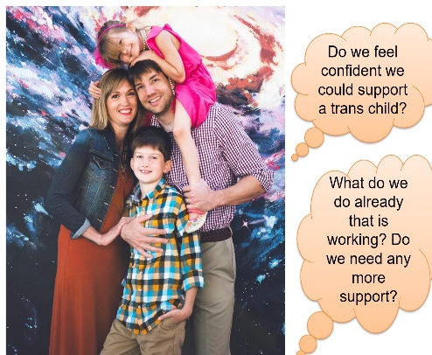
- Building on what you do already to be inclusive
- Why teach about diverse families and gender diversity?
- Outline of my sessions.
- Lots of ideas on how to include diversity in a low-key way so it becomes part of everyday school life.
- Resources – Twinkl, books, websites and organisations, etc
- Logging incidents, The Equality Act 2010, Ofsted guidelines and CoE guidelines
- Lots of opportunities for discussion and to ask questions.

Training for Staff Allies (1 hour)
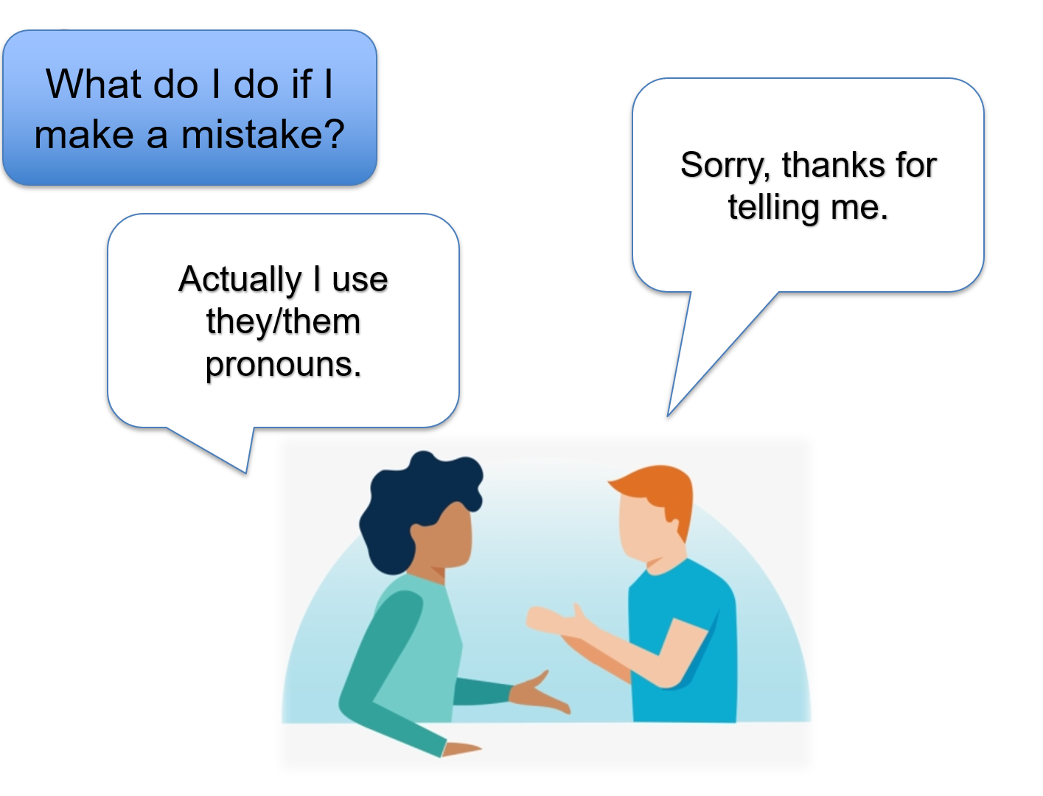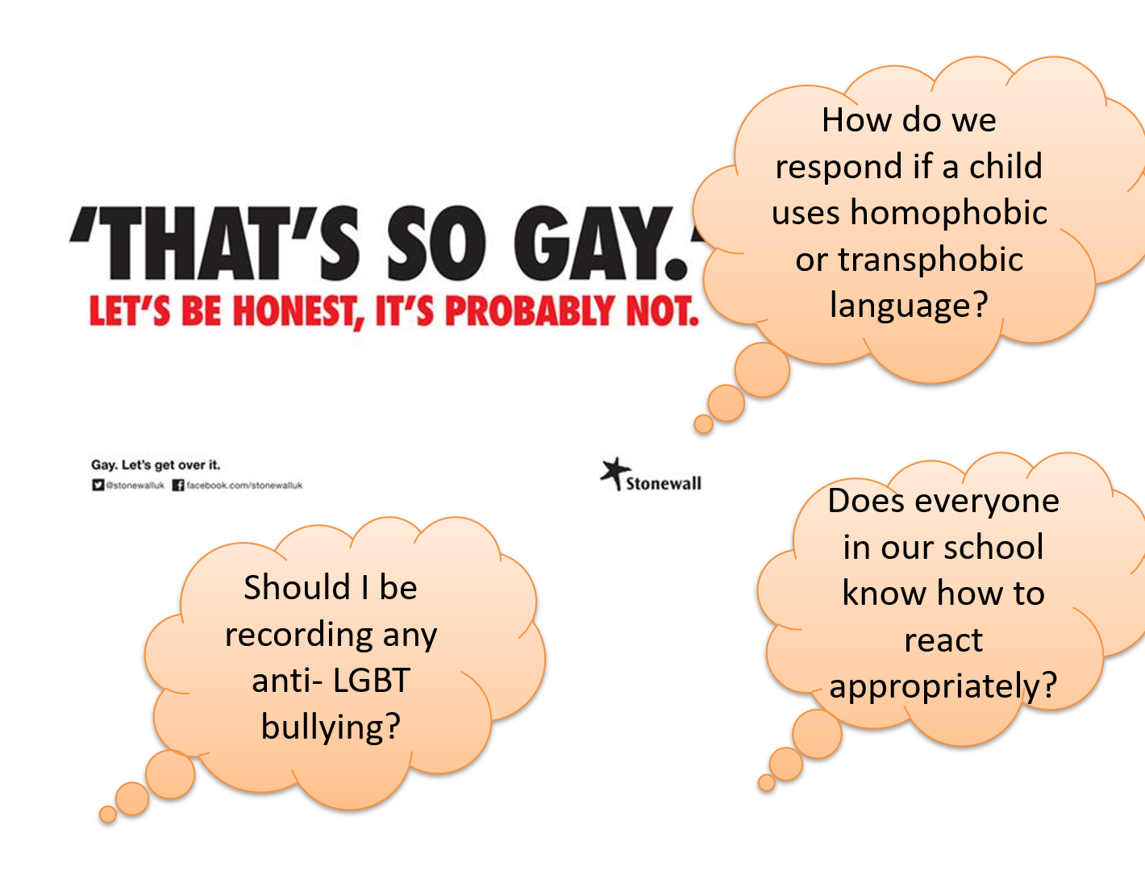

- Being a positive ally, eg visibility and support
- Issues facing young LGBT+ people
- How to support someone coming out
- Lots of guidance and where to go for advice
- Plenty of time for discussion and questions throughout

