Different Families – Same Love
Inclusive books about Families for KS1 (and beyond)
www.diversitymel.com

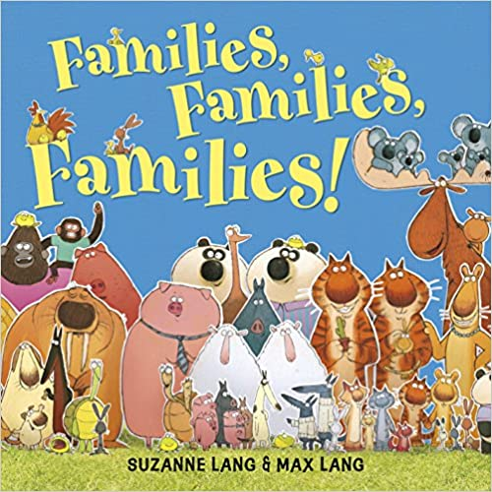
If you love each other, then you’re a family . . .
Do you have two dads? Or one step mum? Or what about the world’s biggest grandpa?
Discover a whole host of silly animal families in this hilarious celebration of the love found in families big and small.
A really lovely, inclusive book

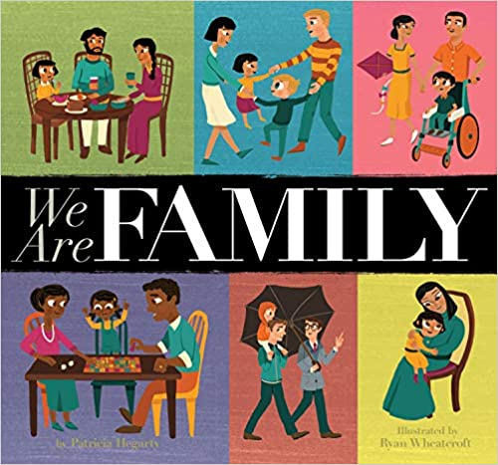
Through illness and health, in celebration and disappointment, families stick together. Some families are made up of many people, and some are much smaller. Sometimes family members look like each other, and sometimes they don't! But even though every family is different, the love is all the same.
Lots of lovely pictures to explore in this inclusive book.

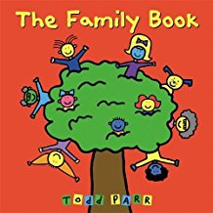
The Family Book celebrates the love we feel for our families and all the different varieties they come in. Whether you have two mothers or two dads, a big family or a small family, a clean family or a messy one, Todd Parr assures readers that no matter what kind of family you have, every family is special in its own unique way.

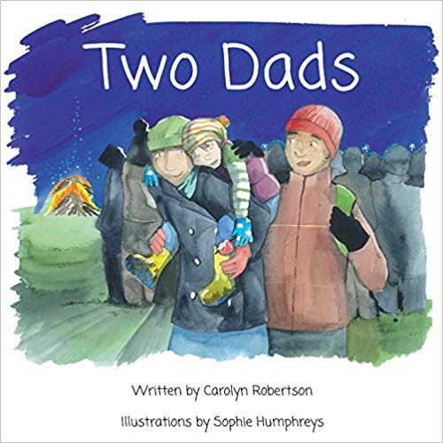
Having Two Dads is double the fun! Many families are different, this family has Two Dads. A beautifully illustrated, affirming story of life with Two Dads, written from the perspective of their adopted child.

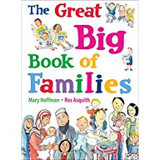
This fun and fascinating treasury features all kinds of families and their lives together. Each spread showcases one aspect of home life-from houses and holidays, to schools and pets, to feelings and family trees. Ros Asquith's humorous illustrations perfectly complement a charming text from the acclaimed Mary Hoffman; kids will love poring over these pages again and again. A celebration of the diverse fabric of kith and kin the world over.

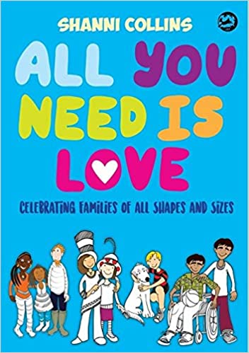
All families come in different shapes and sizes, but they are all special when they love and respect each other. These rhyming stories are a celebration of the diversity of families and encourage inclusion and acceptance in a child's relationships.

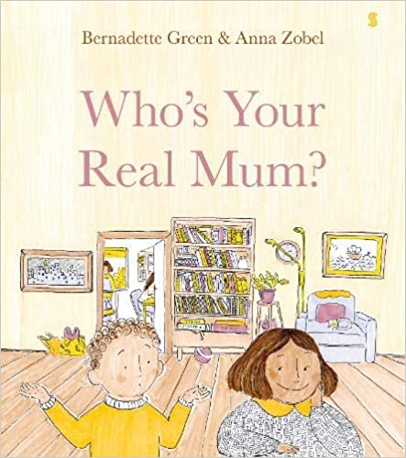
A beautifully illustrated story, written with a light and humorous touch, that celebrates nontraditional families and captures exactly what lies at the heart of family life ― love.

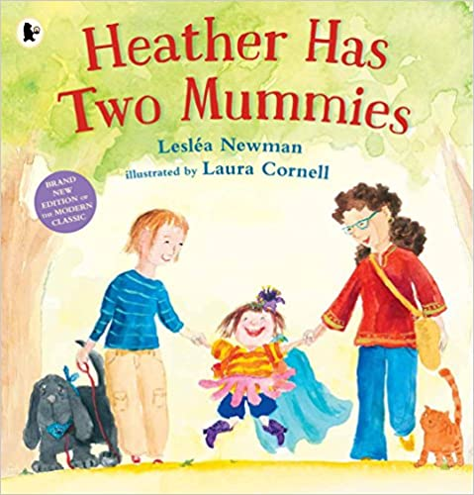
Heather’s favourite number is two – she has two arms, two legs, two pets and two lovely mummies. But when Heather goes to school for the first time, someone asks her about her daddy ... and Heather doesn't have a daddy! But then the class all draw portraits of their families, and not one single drawing is the same. Heather and her classmates realize – it doesn’t matter who makes up a family, the most important thing is that all the people in it love one another very much.

