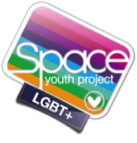
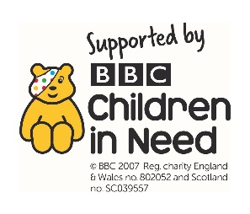
Suggested Resources to promote inclusion
in your classroom – SECONDARY AGE

Teaching Resources – Books
www. DiversityMel.com

Non-Fiction

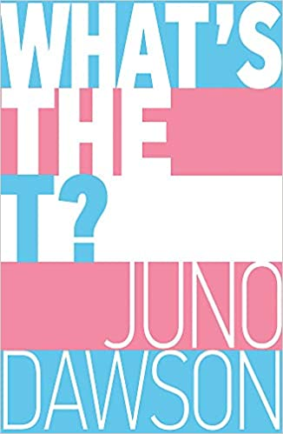
What’s the T? by Juno Dawson
Discover what it means to be a young transgender and/or non-binary person in the twenty-first century in this frank and funny guide for teens (but also very useful for adults too). In What's the T?, Juno Dawson defines a myriad of labels and identities and offers advice on coming out, sex and relationships with her trademark humour and lightness of touch. Juno has also invited her trans and/or non-binary friends to make contributions, ensuring this inclusive book reflects as many experiences as possible, and features the likes of Travis Alabanza and Jay Hulme. What's the T? tackles the complex realities of growing up trans with honesty and humour, and is joyfully illustrated by gender non-conforming artist Soofiya.

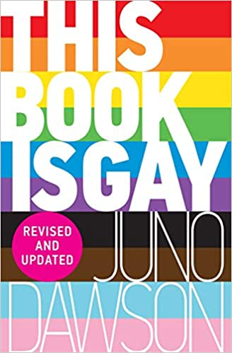
This Book is Gay by Juno Dawson
A funny and pertinent book about being lesbian, bisexual, gay, queer, transgender or just curious - for everybody, no matter their gender or sexuality
Former PSHCE teacher and acclaimed YA author Juno Dawson gives an uncensored look at what it's like to grow up as LGBT. Including testimonials from people across the gender and sexual spectrums, this frank, funny, fully inclusive book explores everything anyone who ever dared to wonder wants to know - from sex to politics, how to pull, stereotypes, how to come-out and more. Suitable for older teens

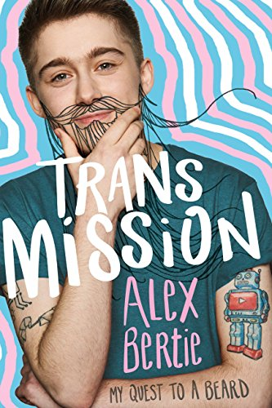
Trans Mission – My Quest to a Beard by Alex Bertie
When I was 15, I realised I was a transgender man. That makes it sound like I suddenly had some kind of lightbulb moment. In reality, coming to grips with my identity has taken a long time. Over the last six years, I've come out to my family and friends, changed my name, battled the healthcare system, started taking male hormones and have had surgery on my chest. My quest to a beard is almost complete. This is my story.
A lively and personal story with practical advice from the positive and cheery Alex Bertie

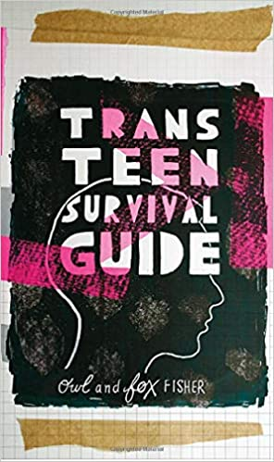
Trans Teen Survival Guide by Owl and Fox Fisher
Frank, friendly and funny, the Trans Teen Survival Guide will leave transgender and non-binary teens informed, empowered and armed with all the tips, confidence and practical advice they need to navigate life as a trans teen. Wondering how to come out to your family and friends, what it's like to go through cross hormonal therapy or how to put on a packer? Trans youth activists Fox and Owl have stepped in to answer everything that trans teens and their families need to know.
With a focus on self-care, expression and being proud of your unique identity, the guide is packed full of invaluable advice from people who understand the realities and complexities of growing up trans. Having been there, done that, Fox and Owl are able to honestly chart the course of life as a trans teen, from potentially life-saving advice on dealing with dysphoria or depression, to hilarious real-life awkward trans stories.

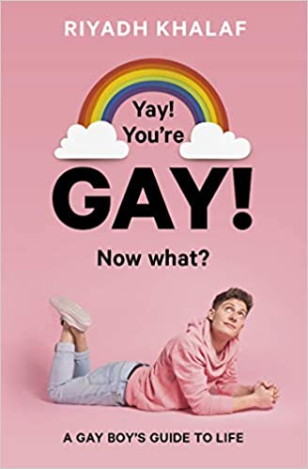
Yay! You’re Gay! Now What? By Riyadh Khalaf
In this personal, heartfelt go-to guide for young queer guys, broadcaster, YouTuber and LGBT+ advocate Riyadh Khalaf shares frank advice about everything from coming out to relationships, as well as encouragement for times when you’re feeling low. There’s a support section for family and friends written by Riyadh’s parents and LOADS of hilarious, embarrassing, inspiring and moving stories from gay boys from around the world. Plus inspirational gay men including Stephen Fry, Clark Moore and James Kavanagh share the advice they would give to their younger selves.
Packed with practical advice and bright, quirky illustrations and photos, this book contains chapters on labels, coming out, dealing with bullies, learning to love your body, sex ed for gay boys, consent, healing heartbreak and finding your tribe.

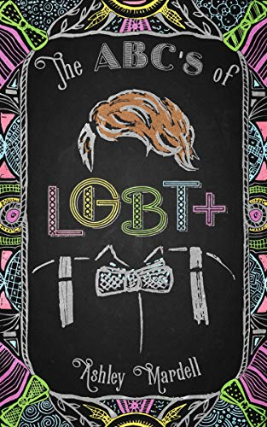
The ABCs of LGBT+ by Ashley Mardell
The ABCs of LGBT+ is essential reading for questioning teens, teachers or parents looking for advice, or anyone who wants to learn how to talk about gender and sexual identity. In this volume, popular vlogger Ash Mardell, who embraces all pronouns, answers your questions about the post-binary world of the twenty-first century.
With in-depth definitions, personal anecdotes, helpful infographics, resources, and more, Mardell lets readers know that it really does get better when we are empowered by information and understanding. In Mardell’s own words, "This book is also for allies and LGBT+ people simply looking to pack in some extra knowledge . . . a critical part of acceptance. Learning about new identities broadens our understanding of humanity, heightens our empathy, and allows us different, valuable perspectives.”

Fiction

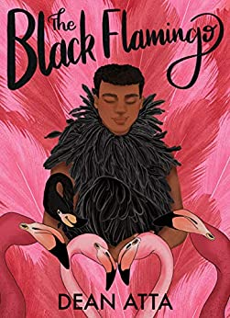
The Black Flamingo by Dean Atta
This is not about being ready, it's not even about being fierce, or fearless, it’s about being free. Michael waits in the stage wings, wearing a pink wig, pink fluffy coat and black heels. One more step will see him illuminated by spotlight. He has been on a journey of bravery to get here, and he is almost ready to show himself to the world in bold colours ...Can he emerge as The Black Flamingo?
WINNER OF THE STONEWALL BOOK AWARD
Big hearted and dizzyingly flamboyant, Atta’s verse novel about a black gay teen reclaiming his identity as a drag artist is an outspoken triumph from the opening couplet to the last.

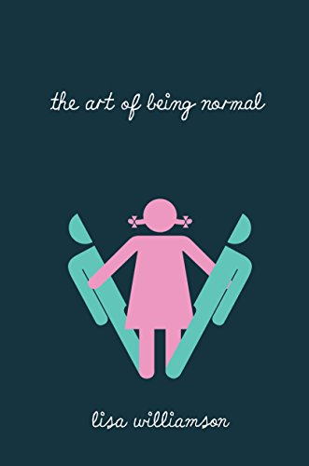
The Art of Being Normal by Lisa Williamson
David Piper has always been an outsider. His parents think he's gay. The school bully thinks he's a freak. Only his two best friends know the real truth - David wants to be a girl. On the first day at his new school Leo Denton has one goal - to be invisible. Attracting the attention of the most beautiful girl in Year 11 is definitely not part of that plan. When Leo stands up for David in a fight, an unlikely friendship forms. But things are about to get messy. Because at Eden Park School secrets have a funny habit of not staying secret for long...
A heart-warming and life-affirming novel with characters you can’t help root for.

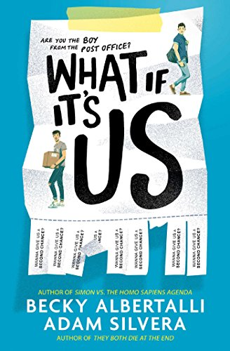
What’ If It’s Us by Becky Abertalli and Adam Silvera
Meet Arthur and Ben. Arthur is only in New York for the summer, but if Broadway has taught him anything, it’s that the universe can deliver a showstopping romance when you least expect it. Ben thinks the universe needs to mind its business. If the universe had his back, he wouldn’t be carrying a box of his ex-boyfriend’s things.
But when the boys have a chance meeting at the post office, they leave wondering what exactly the universe does have in store for them.
A happy and positive gay love story for younger teens.

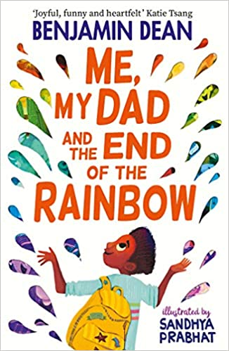
Me, My Dad and the End of the Rainbow by Sandhya Prabhat
Things aren't going well for Archie Albright. His dad's acting weird, his mum too, and all he wants is for everything to go back to normal, to three months before when his parents were happy and still lived together. When Archie sees a colourful, crumpled flyer fall out of Dad's pocket, he thinks he may have found the answer. Only problem? The answer might just lie at the end of the rainbow, an adventure away. Together with his best friends, Bell and Seb, Archie sets off on a heartwarming and unforgettable journey to try and fix his family, even if he has to break a few rules to do it...
This is a lovely book, suitable for UKS2 and younger teens.

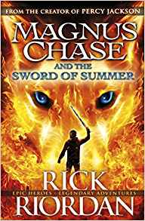
The Magnus Chase trilogy by Rick Riordan
My name is Magnus Chase. I'm orphaned and living rough on the streets of Boston. And things are about to get much worse.
Rick Riordan reliably entertains in this Norse-themed drama.
The varied cast of characters includes non-binary Alex, devout muslim Samira al-abbas, with her magical headscarf and deaf, magical elf Hearthstone, master of the magic runes.
Suitable for KS2 and younger teens

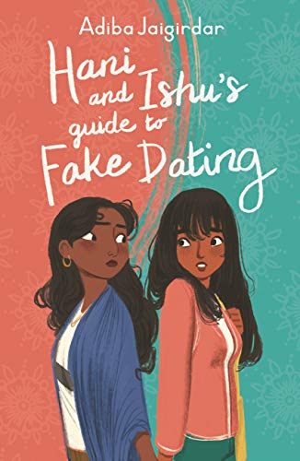
Hani and Ishu’s Guide to Fake Dating by Adiba Jagirdar
Hani and Ishu couldn't be less alike - and they definitely don't like each other. But when fates collide and they pretend to date each other, things start to get messy
Hani is easy going and popular in school, but when she comes out as bisexual her friends don’t believe her. Ishu is her polar opposite – an academic overachiever who hopes to become head girl. The girls agree a mutually beneficial pact to ‘fake date’ but then they start to develop real feelings for each other.
A positive and happy depiction of life and love for two young teen Bengali girls.
Suitable for younger teens

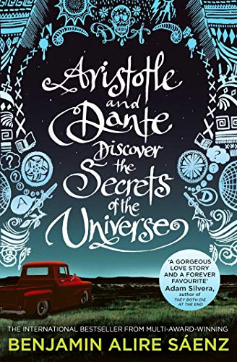
Aristotle and Dante Discover the Secrets of the Universe
By Benjamin Alire Saenz
Aristotle is an angry teen with a brother in prison.
Dante is a know-it-all who has a unique perspective on life.
When the two meet at the swimming pool, they seem to have nothing in common. But as the loners start spending time together, they develop a special friendship – the kind that changes lives and lasts a lifetime. And it is through this friendship that Ari and Dante will learn the most important truths about the universe, themselves and the kind of people they want to be.
This incredibly moving and powerful Printz Honor Book follows two teen boys learning to open themselves up to love, despite the world being against them.
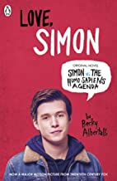
Love, Simon by Becky Abertelli
Simon Spier is sixteen and trying to work out who he is - and what he's looking for.
But when one of his emails to the very distracting Blue falls into the wrong hands, things get all kinds of complicated.
Because, for Simon, falling for Blue is a big deal ...
The warm and readable gay romance – the book the inspired the film

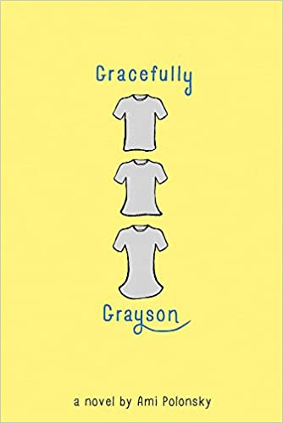
Gracefully Grayson by Ami Polonsky
What if who you are on the outside, doesn’t match with who you are on the inside?
A powerful novel about identity, self-esteem, acceptance and one student's journey to self-discovery.
Grayson Sender has been holding onto a secret for what seems like forever: 'he' is a girl on the inside. The weight of this secret is crushing, but sharing it would mean facing ridicule, scorn, rejection or worse. Despite the risks, Grayson's true self itches to break free. Will new strength from an unexpected friendship and a caring teacher's wisdom be enough to help Grayson step into the spotlight she was born to inhabit?
Debut author Ami Polonsky's moving, beautifully-written novel about identity, self-esteem and friendship shines with the strength of a young person's spirit and the enduring power of acceptance.
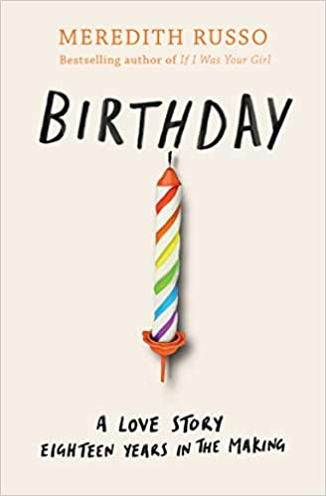
Birthday by Meredith Russo
Meet Eric and Morgan. Born on the same day, at the same time, in the same place.
They've always shared this one day together, but as they grow up they begin to grow apart. Everyone expects Eric to get a football scholarship, but no one knows he's having second thoughts. Former quarterback Morgan feels utterly alone, as she wrestles with the difficult choice to live as her true self. Both of them are struggling to be the person they know they are. Who better to help than your best friend?
Told on one day every year, over six years, this is a story about how change pulls people apart… and how love brings them back together.
This is one of the most beautiful and emotional tale about identity, bullying, trans, bereavement, domestic abuse and more.

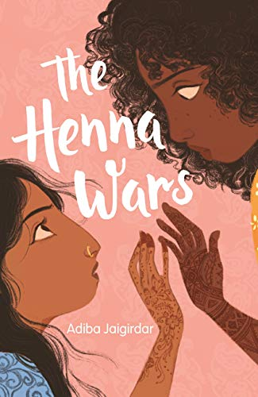
The Henna Wars by Adiba Jagirdar
When Nishat comes out to her parents, they say she can be anyone she wants - as long as she isn't herself. Because Muslim girls aren't lesbians. Nishat doesn't want to lose her family, but she also doesn't want to hide who she is, which only gets harder once Flávia walks into her life.
Beautiful and charismatic, Flávia takes Nishat's breath away. But as their lives become tangled, they're caught up in a rivalry that gets in the way of any feelings they might have for each other.
Can Nishat find a way to be true to herself... and find love too?
Adiba Jaigirdar is a stunning new voice in young adult fiction, writing uplifting, authentic stories from a Bengali-Irish perspective.

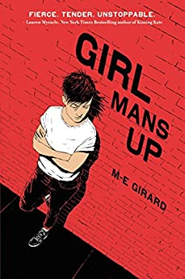
Girl Mans Up by M-E Girard
All Pen wants is to be the kind of girl she’s always been. So why does everyone have a problem with it? They think the way she looks and acts means she’s trying to be a boy—that she should quit trying to be something she’s not. If she dresses like a girl, and does what her folks want, it will show respect. If she takes orders and does what her friend Colby wants, it will show her loyalty. But respect and loyalty, Pen discovers, are empty words. Old-world parents, disintegrating friendships, and strong feelings for other girls drive Pen to see the truth—that in order to be who she truly wants to be, she’ll have to man up.
A powerful book about identity, belonging, and the collision between sexuality and cultural expectations
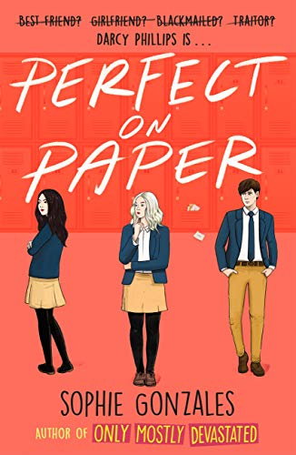
Perfect on Paper by Sophie Gonzales
Darcy Phillips can give you the solution to any of your relationship woes - for a fee.
When Brougham catches Darcy in the act of collecting letters from locker 89 she begrudgingly agrees to become his personal dating coach in exchange for keeping her secret. The goal? To help him win his ex-girlfriend back.
A sweet, positive Romance featuring a bisexual central character and a supportive Queer and Questioning Club.

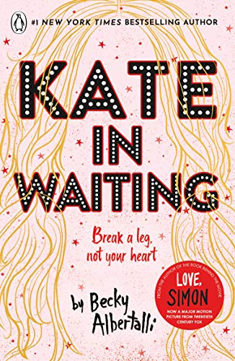
Kate in Waiting by Becky Albertelli
Kate and Anderson have always enjoyed the thrill of sharing their crushes, but when the object of their long-distance attention turns up at their school it turns out that communal crushes aren’t so fun.
A sweet and funny rom-com with a diverse LGBTQ cast

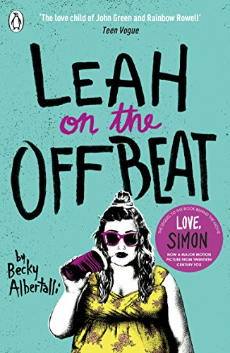
Leah on the Offbeat by Becky Albertelli
When it comes to drumming, Leah Burke is usually on beat- but real life isn't always so rhythmic. The only child of a single mum, her life is less privileged than her friends. Her mum knows she's bisexual, but Leah hasn't mustered the courage to tell her friends.
Not even her openly gay BFF, Simon. Prom and college are on the horizon, and tensions are running high. Can Leah still strike the right note, when the people she loves are fighting? And how can she cope knowing that she might love one of her friends more than she ever intended?
A fresh and funny novel with a relatable central character

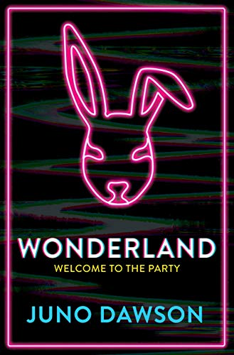
Wonderland by Juno Dawson
Alice lives in a world of stifling privilege and luxury - but none of it means anything when your own head plays tricks on your reality. When her troubled friend Bunny goes missing, Alice becomes obsessed with finding her. On the trail of her last movements, Alice discovers a mysterious invitation to 'Wonderland': the party to end all parties - three days of hedonistic excess to which only the elite are welcome. Will she find Bunny there? Or is this really a case of finding herself? Because Alice has secrets of her own, and ruthless socialite queen Paisley Hart is determined to uncover them, whatever it takes. Alice is all alone, miles from home, and now she has a new enemy who wants her head...
A searing exploration of mental health, gender and privilege, suitable for older teens

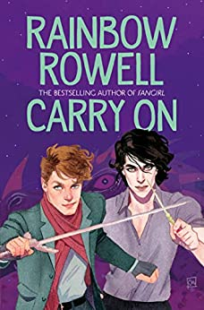
Carry On (The Simon Snow Trilogy) by Rainbow Rowell
Simon Snow just wants to relax and savour his last year at the Watford School of Magicks, but no one will let him. His girlfriend broke up with him, his best friend is a pest and his mentor keeps trying to hide him away in the mountains where maybe he'll be safe. Simon can't even enjoy the fact that his room-mate and longtime nemesis is missing, because he can't stop worrying about the evil git. Plus there are ghosts. And vampires. And actual evil things trying to shut Simon down. When you're the most powerful magician the world has ever known, you never get to relax and savour anything.

A warm-hearted gay romance/ ghost story/ mystery/ melodrama

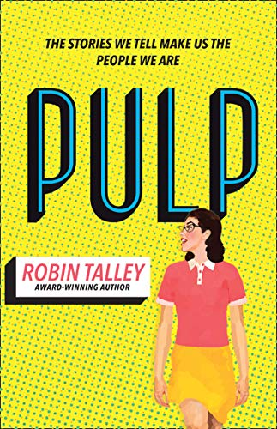
Pulp by Robin Talley
In 1955 eighteen-year-old Janet Jones must keep the love she shares with her best friend a secret. As in the age of McCarthyism to be gay is to sin. But when Janet discovers a series of books about women falling in love with other women, it awakens something in her. As she juggles a romance she must keep hidden and a new-found ambition to write and publish her own story, she risks exposing herself – and Marie – to a danger all too real.
Sixty-two years later, Abby Cohen can’t stop thinking about her senior project – classic 1950s lesbian pulp fiction. She feels especially connected to one author, ‘Marian Love’, and becomes determined to track her down and discover her true identity. Is Abby prepared for what she will find?
A stunning story of bravery, love, how far we’ve come and how much farther we have to go.

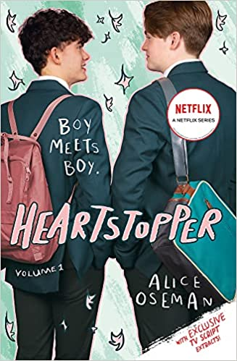
Heartstopper by Alice Oseman – A Graphic Novel
Charlie and Nick are at the same school, but they've never met ... until one day when they're made to sit together. They quickly become friends, and soon Charlie is falling hard for Nick, even though he doesn't think he has a chance.
But love works in surprising ways, and Nick is more interested in Charlie than either of them realised.
By Alice Oseman, winner of the YA Book Prize, Heartstopper is about love, friendship, loyalty and mental illness. It encompasses all the small stories of Nick and Charlie's lives that together make up something larger, which speaks to all of us.

