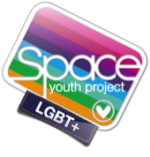
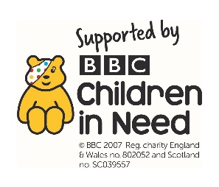
Suggested Resources to promote inclusion
in your classroom

Teaching Resources - Books
(Some book descriptions courtesy of Amazon)

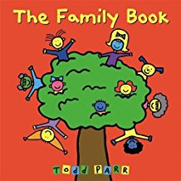
The Family Book by Todd Parr
The Family Book celebrates the love we feel for our families and all the different varieties they come in. Whether you have two mothers or two dads, a big family or a small family, a clean family or a messy one, Todd Parr assures readers that no matter what kind of family you have, every family is special in its own unique way.

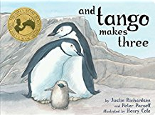
And Tango Makes Three by Justin Richardson
The heartwarming true story of two penguins who create a nontraditional family. At the penguin house at the Central Park Zoo, two penguins named Roy and Silo were a little bit different from the others. But their desire for a family was the same. And with the help of a kindly zookeeper, Roy and Silo got the chance to welcome a baby penguin of their very own.

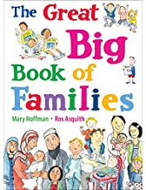
The Great Big Book of Families by Mary Hoffman
This fun and fascinating treasury features all kinds of families and their lives together. Each spread showcases one aspect of home life-from houses and holidays, to schools and pets, to feelings and family trees. Ros Asquith's humorous illustrations perfectly complement a charming text from the acclaimed Mary Hoffman; kids will love poring over these pages again and again. A celebration of the diverse fabric of kith and kin the world over.

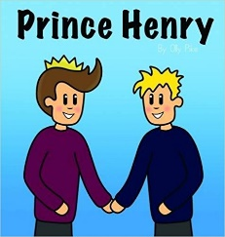
Prince Henry by Olly Pike
It is time for Prince Henry to find someone to marry, or so his parents think. Join Henry in his fairytale kingdom where certain laws apply when its comes to choosing who you can spend your life with. Princes are definitely not meant to marry their poor servants! A fairytale romance intended for young readers, 'Prince Henry' delivers a positive message of both love and equality.

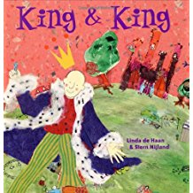
King and King by Linda de Haan
The queen decrees that it is time for the prince to marry and the search is on! Princesses come from far and wide hoping to catch his eye. The prince fails to be charmed by any of them, until one princess turns up with her brother and it is love at first sight. A wedding follows and everyone lives happily ever after.
A very simple book for younger children, focussing on the traditional tale and the power of love.

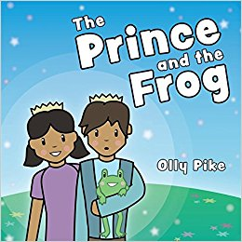
The Prince and the Frog by Olly Pike
One day, Oskar and his sister Caroline meet a prince who was turned into a frog by an evil wizard. Only true love's kiss can break the spell - both Caroline and Oskar want to help, but which of them will be the frog prince's true love?
This brightly illustrated, heart-warming take on a classic fairytale teaches children about same-sex relationships and attraction. Exploring what it means to be in a healthy, loving relationship, it encourages children to listen to others, be kind, and embrace diversity and equality. Ideal for children age 3-7.

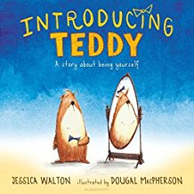
Introducing Teddy by Jessica Walton
Errol and his teddy, Thomas, are best friends who do everything together. One day, Errol finds that Thomas is sad and he can't figure out why. Eventually Thomas finally tells Errol what the teddy has been afraid to say: "In my heart, I've always known that I'm a girl teddy, not a boy teddy. I wish my name was Tilly, not Thomas. Errol replies, "I don't care if you're a girl teddy or a boy teddy! What matters is that you are my friend. Introducing Teddy introduces the youngest readers to understanding gender identity and transition in an accessible and heart-warming story about being true to yourself and being a good friend.

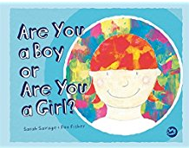
Are You a Boy or a Girl by Fox Fisher
Tiny loves costumes! Tiny likes to dress up as an animal, or a doctor, or a butterfly. Tiny also prefers not to tell other children whether they are a boy or a girl. Tiny's friends don't mind, but when Tiny starts a new school their new friends can't help asking one question: "Tiny, are you a boy or are you a girl?"
This brightly illustrated book opens a dialogue with children aged 3+ about gender diversity in a fun and creative way. Featuring a gender neutral protagonist, the book imparts an important message about identity and being who you want to be.

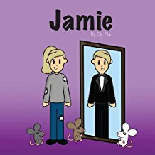
Jamie by Olly Pike
Jamie doesn't have a fairy godmother to help her to grant her every wish, so she finds her own way to the ball (with a little help from the mice), making her own clothes, creating her own transportation and cutting her hair so she finally feels right. Jamie has never felt like a girl, so he is delighted to attend the palace ball and fall in love with the princess. He is honest with her about who he is and she falls in love too. Jamie loves the fact that he no longer needs to wear a disguise and he can be himself. This book is great for introducing younger readers to the concept of gender and being true to how you feel inside.
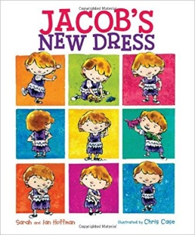
Jacob’s New Dress by Sarah and Ian Hoffman
Jacob loves playing dress-up, when he can be anything he wants to be. Some kids at school say he can't wear "girl" clothes, but Jacob wants to wear a dress to school. Can he convince his parents to let him wear what he wants? This heartwarming story speaks to the unique challenges faced by boys who don't identify with traditional gender roles.

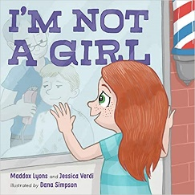
I’m not a Girl byMaddox Lyons and Jessica Verdi
Based on a true transgender identity journey, the picture book I'm Not a Girl is an empowering story about a boy who is determined to be himself. Nobody seems to understand that Hannah is not a girl. His parents ask why he won't wear the cute outfits they pick out. His friend thinks he must be a tomboy. His teacher insists he should be proud to be a girl. But a birthday wish, a new word, and a stroke of courage might be just what Hannah needs to finally show the world who he really is.

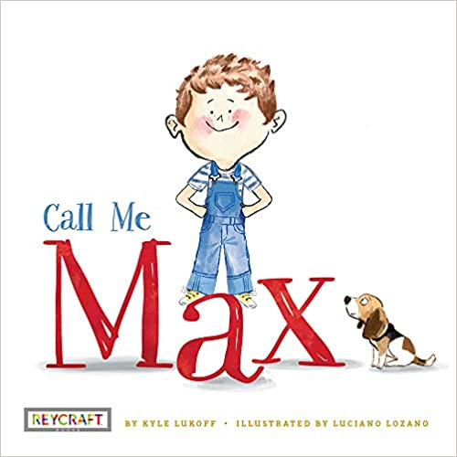
Call Me Max by Kyle Luckoff
When Max starts school, the teacher hesitates to call out the name on the attendance sheet. Something doesn't seem to fit. Max lets he know the name he wants to be called by‚"Max‚"a boy's name. This begins Max's journey as he makes new friends and reveals his feelings about his identity to his parents. Written with warmth and sensitivity by trans writer Kyle Lukoff, this book is a sweet and age-appropriate introduction to what it means to be transgender.

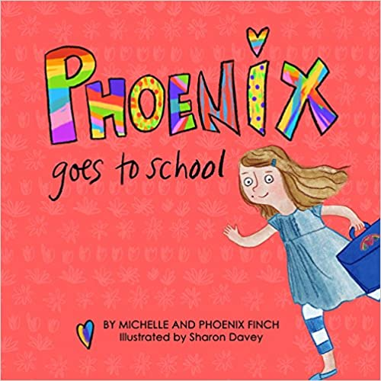
Phoenix Goes to School by Michelle and Phoenix Finch
My Mommy tells me I'm perfect and to be brave.
"You know who you are," she says,
"Just be yourself and always listen to your heart."
With those words of encouragement from her Mom, Phoenix is preparing for her first day of school. She is excited but scared of being bullied because of her gender identity and expression. Yet when she arrives at school she finds help and support from teachers and friends, and finds she is brave enough to talk to other kids about her gender! This is an empowering and brightly-illustrated children's book for children aged 3+ to help children engage with gender identity in a fun, uplifting way.
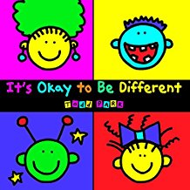
It’s OK to be Different by Todd Parr
It's okay to need some help.
It's okay to be a different color.
It's okay to talk about your feelings.
From the bestselling author Todd Parr comes a reassuring book about being who you are. Told with Todd Parr's signature wit and wisdom, It's Okay to Be Different cleverly delivers the important messages of acceptance, understanding, and confidence in an accessible, child-friendly format.
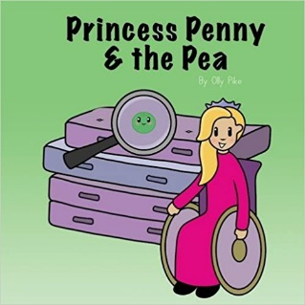
Princess Penny and the Pea by Olly Pike
The princess encounters a talking pea, but before she can befriend it her advisers swoop in to perform lots of tests on it. The pea is tested to its limits, much to the frustration of the princess, who eventually calls a halt and insists that the pea is allowed to just be a pea, like all the other peas. Princess Penny throws the pea into her mouth and the pea is delighted - finally it is being treated like all the other peas.
A clever twist on the traditional story which encourages younger readers to treat everyone equally, even if they're not exactly the same as them.
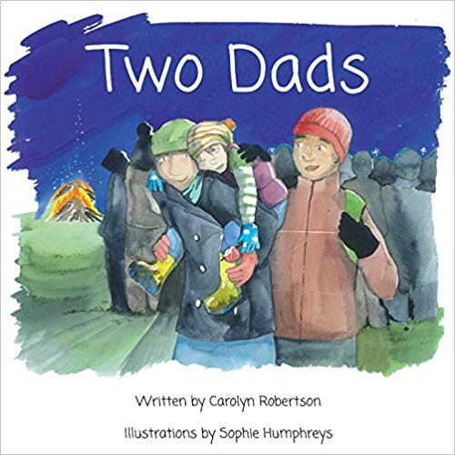
Two Dads by Carolyn Robertson
Having Two Dads is double the fun! Many families are different, this family has Two Dads. A beautifully illustrated, affirming story of life with Two Dads, written from the perspective of their adopted child.

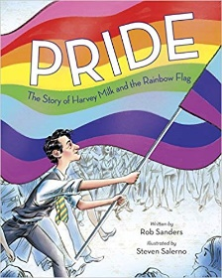
Pride – The Story of Harvey Milk and the Rainbow Flag by Rob Sanders
The very first picture book about the remarkable and inspiring story of the Gay Pride Flag! In this deeply moving and empowering true story, young readers will trace the life of the Gay Pride Flag, from its beginnings in 1978 with social activist Harvey Milk and designer Gilbert Baker to its spanning of the globe and its role in today''s world. Award-winning author Rob Sanders's stirring text, and acclaimed illustrator Steven Salerno's evocative images, combine to tell this remarkable - and undertold - story. A story of love, hope, equality, and pride.

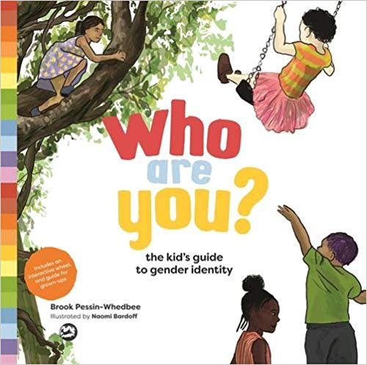
Who are You? byBrooke Pessin-Whedbee
This brightly illustrated children's book provides a straightforward introduction to gender for anyone aged 5+. It presents clear and direct language for understanding and talking about how we experience gender: our bodies, our expression and our identity. An interactive three-layered wheel included in the book is a simple, yet powerful, tool to clearly demonstrate the difference between our body, how we express ourselves through our clothes and hobbies, and our gender identity. Ideal for use in the classroom or at home, a short page-by-page guide for adults at the back of the book further explains the key concepts and identifies useful discussion points.

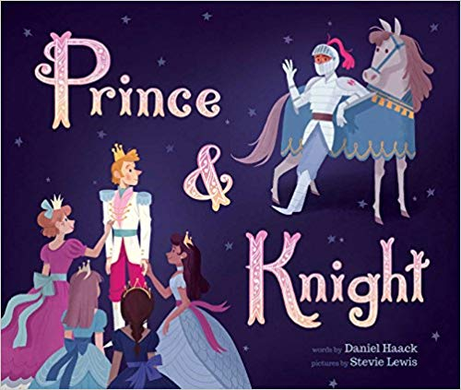
Prince and Knight by Daniel Haack
Once upon a time, in a kingdom far from here, there was a prince in line to take the throne, so his parents set out to find him a kind and worthy bride. The three of them traveled the land far and wide, but the prince didn't quite find what he was looking for in the princesses they met. While they were away, a terrible dragon threatened their land, and all the soldiers fled. The prince rushed back to save his kingdom from the perilous beast and was met by a brave knight in a suit of brightly shining armour. Together they fought the dragon and discovered that special something the prince was looking for all along.

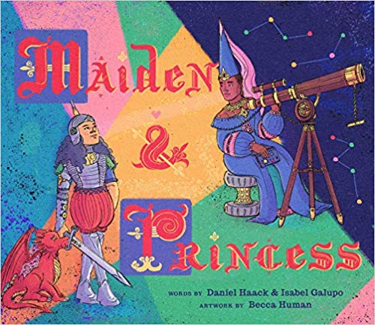
Maiden and Princess by Daniel Haack
In this modern fairy tale, a strong, brave maiden is invited to attend the prince's royal ball, but at the dance, she ends up finding true love in a most surprising place.
Once in a faraway kingdom, a strong, brave maiden is invited to attend the prince's royal ball, but she's not as excited to go as everyone else. After her mother convinces her to make an appearance, she makes a huge impression on everyone present, from the villagers to the king and queen, but she ends up finding true love in a most surprising place.

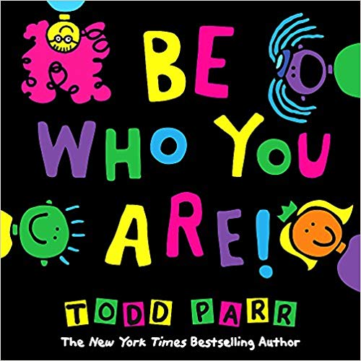
Be Who Your Are! byTodd Parr
Be old. Be young.
Speak your language.
Be proud of where you're from.
Just BE WHO YOU ARE!
Who better than Todd Parr to remind kids that their unique traits are what make them so special? With nods to everything from race to gender expression to economic background,

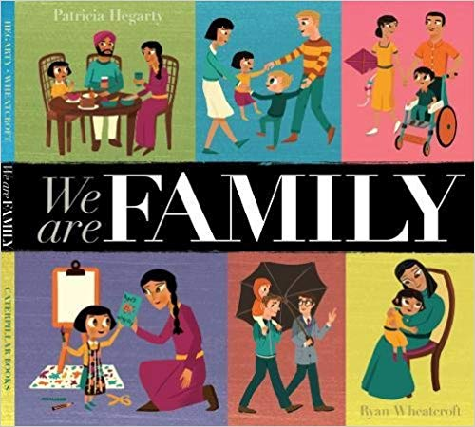
We are Family by Patricia Hegarty
All families are different - and yet in many ways the same!
This book uses a gentle rhyming text to follow eight different families, celebrating their everyday differences as well as the similarities they share.

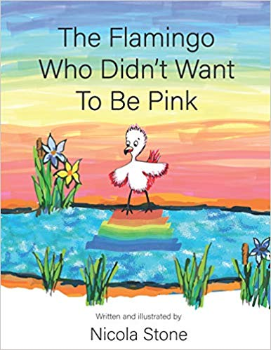
The Flamingo Who Didn’t Want to Be Pink by Nicola Stone
The tiny, pink flamingo chick has noticed her white, baby feathers have begun to turn pink but she doesn't want to be pink! She wanders around the watering hole, admiring the zebras' dazzling stripes and the parrots' rainbow feathers, but they all laugh when she says she wishes not to be pink. She is miserable until she meets a chameleon, who reminds her that we must all be free to choose how we are beautiful, but that being different takes great bravery. A thought-provoking fairytale based on about gender equality, with strong moral messages about freedom, self-expression and the importance of choice.

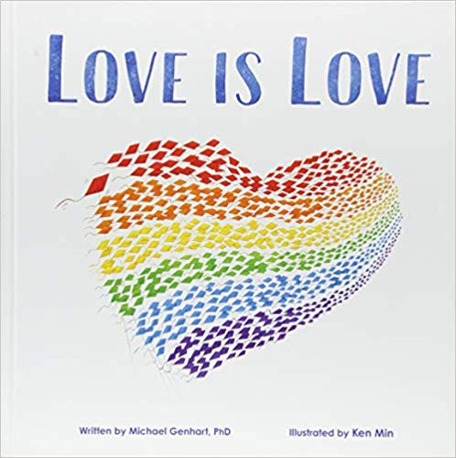
Love is Love by Michael Genhart
Love Is Love empowers young readers to celebrate the family they have - no matter how it's constructed. A boy confides in a friend when he's teased for having two dads and for wearing a shirt that they deem is 'gay.' Kids tell him that they're not a real family, and he doesn't know how to respond. But our narrator realises that his friend's family (with a mum and a dad) isn't all that different from his: they both have parents who love them, and they both love their parents. And it's love that makes a family.

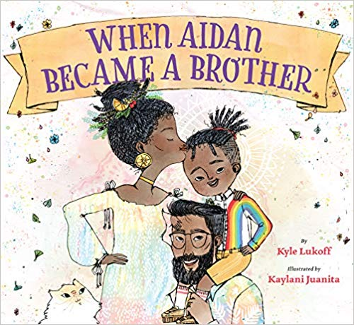
When Aidan Became a Brother by Kyle Luckoff
When Aidan was born, everyone thought he was a girl. His parents gave him a pretty name, his room looked like a girl's room, and he wore clothes that other girls liked wearing. After he realised he was a trans boy, Aidan and his parents fixed the parts of life that didn't fit anymore, and he settled happily into his new life. Then Mom and Dad announce that they're going to have another baby, and Aidan wants to do everything he can to make things right for his new sibling from the beginning - but what does "making things right" actually mean? And what happens if he messes up? With a little help, Aidan comes to understand that mistakes can be fixed with honesty and communication, and that he already knows the most important thing about being a big brother: how to love.
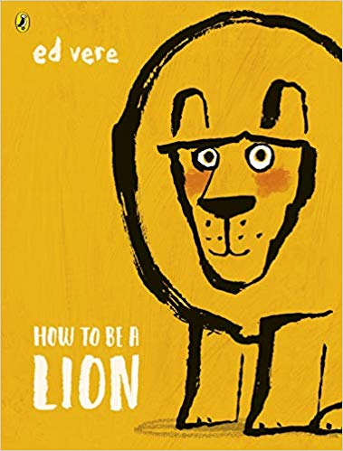
How to be a Lion by Ed Vere
You don't have to ROAR to be heard...
Meet Leonard - a lion like no other. Leonard's best friend is Marianne, a duck. But lions chomp ducks, don't they? What will the pair do when their way of life is threatened?
From a New York Times-bestselling author comes a powerful story celebrating daydreamers, individuality and the quiet courage to be yourself. This is a book celebrating gentleness and strength – it encourages the reader to speak up for themselves and those who are less strong. A gentle read with great power.

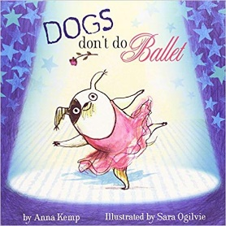
Dogs Don’t Do Ballet by Anna Kemp
Meet Biff, the puppy who will stop at nothing to become a ballet dancer.
My dog is not like other dogs. He doesn't do dog stuff like weeing on lampposts or scratching his fleas, or drinking out of the toilet. No, my dog likes moonlight and music and walking on his tiptoes. You see, my dog doesn't think he's a dog. My dog thinks he's a ballerina!
A fabulous feel-good book about a small dog with a big personality and even bigger dreams.
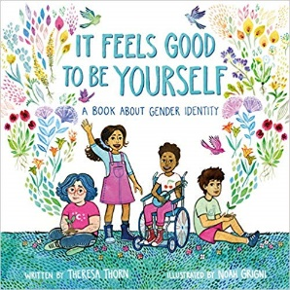
It Feels Good to Be Yourself by Theresa Thorn
Some people are boys. Some people are girls. Some people are both, neither, or somewhere in between. This sweet, straightforward exploration of gender identity will give children a fuller understanding of themselves and others. Written by the mother of a transgender child and illustrated by a non-binary transgender artist, It Feels Good to Be Yourself provides young readers and adults alike with the vocabulary to discuss this important topic with sensitivity.

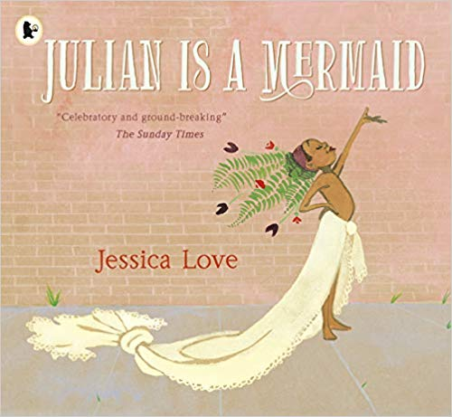
Julian is Mermaid by Jessica Love
While riding the subway home with his Nana one day, Julian notices three women spectacularly dressed up. Their hair billows in brilliant hues, their dresses end in fishtails, and their joy fills the train carriage. When Julian gets home, daydreaming of the magic he's seen, all he can think about is dressing up just like the ladies and making his own fabulous mermaid costume. A lovely book about the power of being yourself.

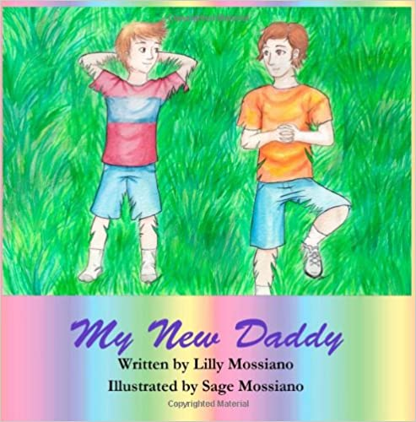
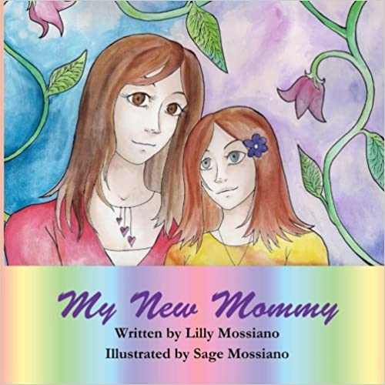
My New Mummy/ My New Daddy by Lily Mossiano
A pair of short fiction books following the transition of a parent. It explains in very simple language accessible for very young children and upwards about the physical and mental changes that might occur as a parent transitions. The emphasis is on love and how their parent might have changed how they look and identify, but they still love their child just the same.

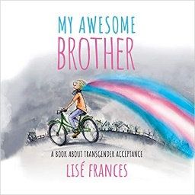
My Awesome Brother by Lise Frances
My Awesome Brother is written from the perspective of a young child whose older sibling is transitioning. It is written for children from very young upwards to start a conversation about gender transitioning and the joys for being able to be yourself.

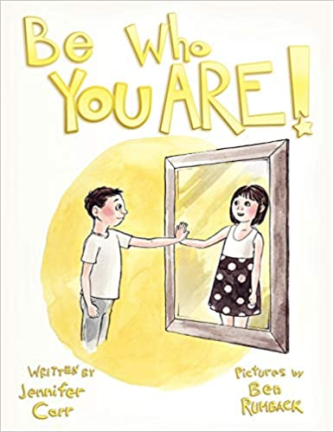
Be Who You Are! by Jennifer Carr
Nick has always seen himself as a girl with a ‘girl’s brain’. He knows his body looks like a boy, but it just doesn’t fit him. Nick’s parents tell him ‘Be who you are’ and support his transition to being Hope. They help explain things to teachers and to help Hope talk to a counsellor and to meet other people who feel the same. The story is one of positivity as everyone around Hope adjusts to the changes and supports her to be herself.

For more confident readers
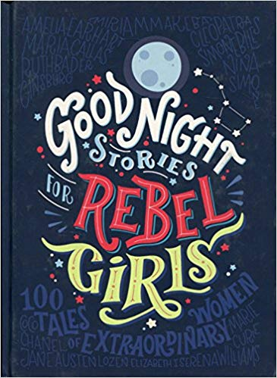
Goodnight Stories for Rebel Girls
What if the princess didn't marry Prince Charming but instead went on to be an astronaut? What if the jealous step sisters were supportive and kind? And what if the queen was the one really in charge of the kingdom? Illustrated by sixty female artists from every corner of the globe, Good Night Stories for Rebel Girls introduces us to one hundred remarkable women and their extraordinary lives, from Ada Lovelace to Malala, Amelia Earhart to Michelle Obama. Empowering, moving and inspirational, these are true fairy tales for heroines who definitely don't need rescuing.

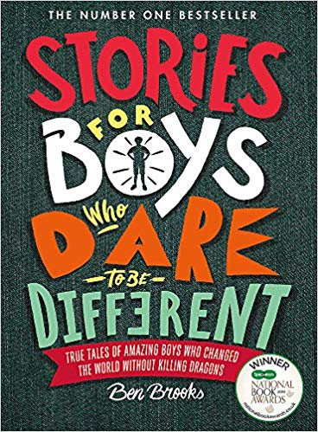
Stories for Boys Who Dare to Be different
As a boy, there is often an assumption that you will conform to a stereotypical idea of masculinity. But what if you're the introvert kind? What if you prefer to pick up a book rather than a sword? What if you want to cry when you're feeling sad or angry? What if you like the idea of wearing a dress?
This book offers a welcome alternative narrative. It is an extraordinary compilation of 100 true stories of famous and not-so-famous men from the past to the present day, every single one of them a rule-breaker and innovator in his own way, and all going on to achieve amazing things.
A beautiful and transporting book packed with stories of adventure and wonderment, it will appeal to those who need the courage to reject peer pressure and go against the grain.

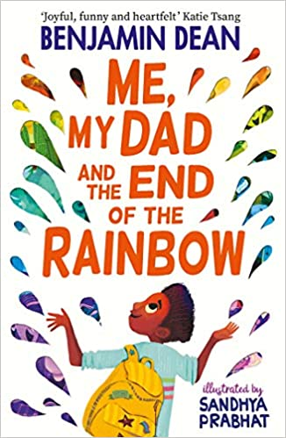
Me, My Dad and the End of the Rainbow by Benjamin Dean
Things aren't going well for Archie Albright. His dad's acting weird, his mum too, and all he wants is for everything to go back to normal, to three months before when his parents were happy and still lived together. When Archie sees a colourful, crumpled flyer fall out of Dad's pocket, he thinks he may have found the answer. Only problem? The answer might just lie at the end of the rainbow, an adventure away. Together with his best friends, Bell and Seb, Archie sets off on a heartwarming and unforgettable journey to try and fix his family, even if he has to break a few rules to do it...
This is a lovely book, suitable for UKS2 and younger teens.

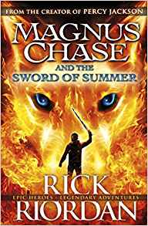
The Magnus Chase trilogy by Rick Riordan
My name is Magnus Chase. I'm orphaned and living rough on the streets of Boston. And things are about to get much worse.
Rick Riordan reliably entertains in this Norse-themed drama.
The varied cast of characters includes non-binary Alex, devout muslim Samira al-abbas, with her magical headscarf and deaf, magical elf Hearthstone, master of the magic runes.

FOR TEACHERS
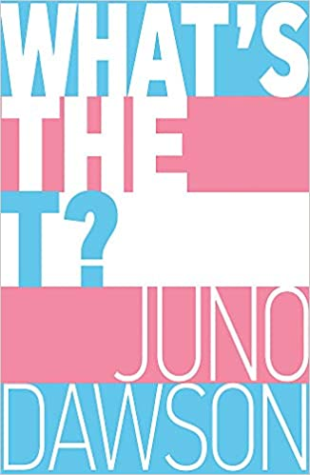
What’s the T? by Juno Dawson
Discover what it means to be a young transgender and/or non-binary person in the twenty-first century in this frank and funny guide for teens (but also very useful for adults too). In What's the T?, Juno Dawson defines a myriad of labels and identities and offers advice on coming out, sex and relationships with her trademark humour and lightness of touch. Juno has also invited her trans and/or non-binary friends to make contributions, ensuring this inclusive book reflects as many experiences as possible, and features the likes of Travis Alabanza and Jay Hulme.What's the T? tackles the complex realities of growing up trans with honesty and humour, and is joyfully illustrated by gender non-conforming artist Soofiya.

Teaching Resources – Websites

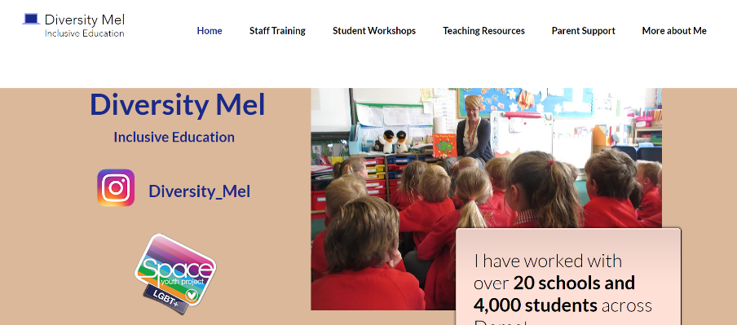
www.DiversityMel.com
Ready-to-use teaching resources to promote discussion.
Resources for parents
Information on staff training

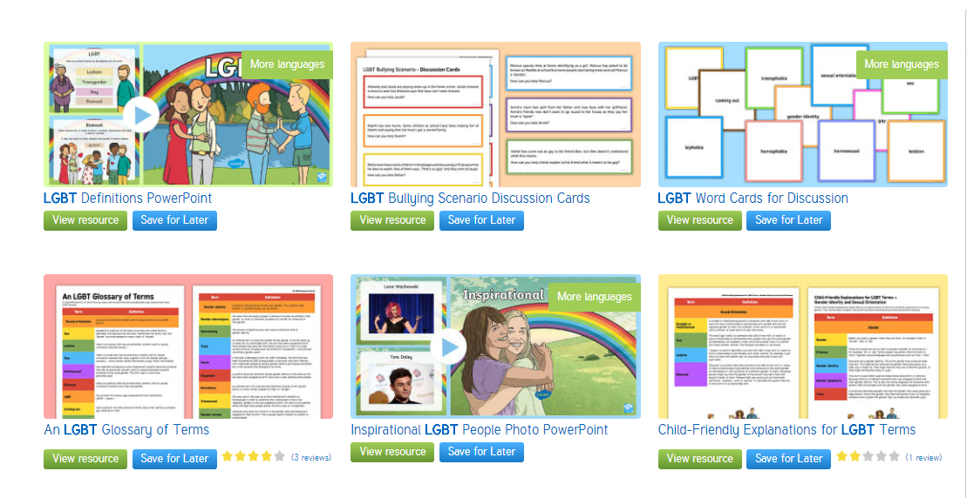
Twinkl have a wide collection of LGBT and Diverse Families resources, including powerpoints, page borders, displays, information, scenario cards for anti-bullying work, and much more.
Twinkl are very responsive to customer feedback. I recently asked them to change their netball powerpoint to show boys as well as girls and they have responded positively to this.

www.popnolly.com
Olly Pike’s website provides teaching resources which match his excellent books on diversity (see booklist). There are suggested lesson plans and links to the Youtube channel where animated versions of the stories can be accessed.

