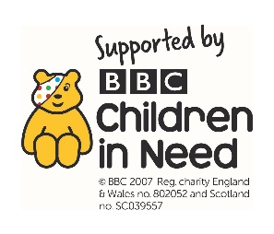
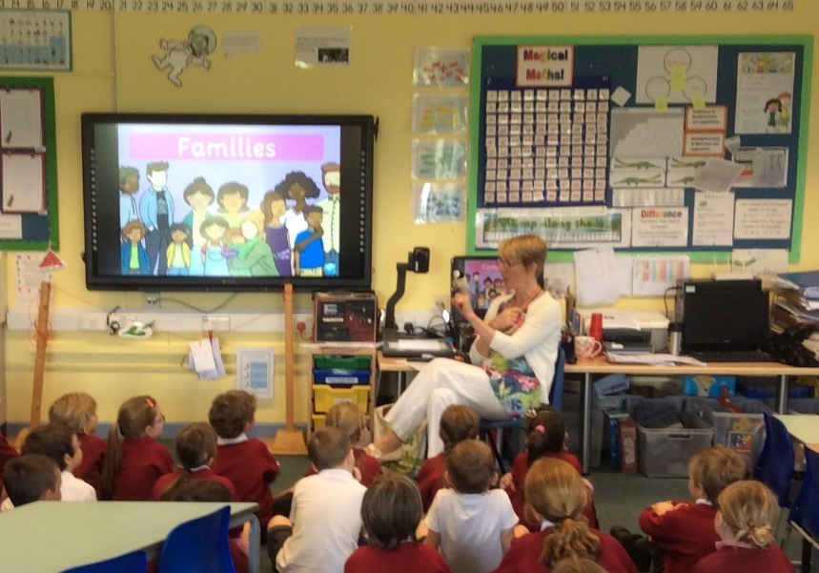
SPACE Youth Project 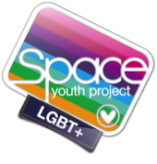 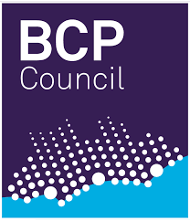

Mel Lane: experienced KS1 and KS2 Teacher www.spaceyouthproject.co.uk
Teacher Trainer and Professional Development Lead education@spaceyouthproject.co.uk

Outline Lesson Plans (First Visits)
All lessons follow Ofsted, Church of England, PSHE and Rights Respecting Schools Guidelines.

Reception/ KS1 (30 mins)
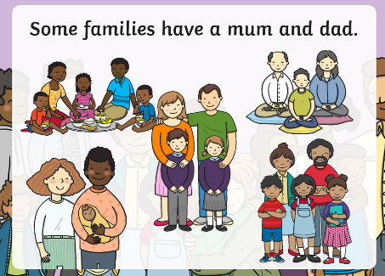
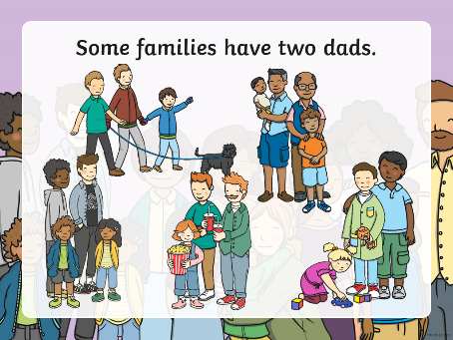
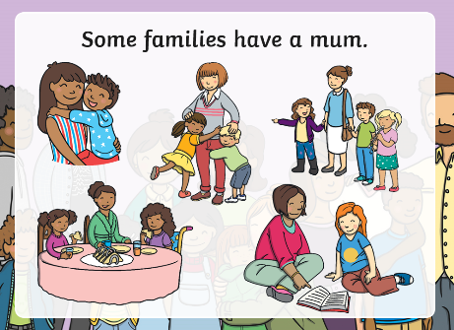
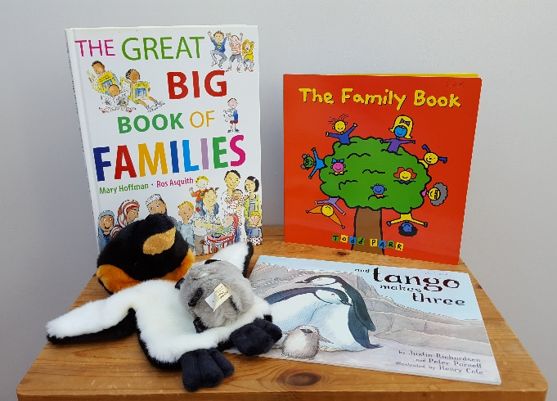

Introduce Tango and read ‘and Tango Makes Three’- the true story of a penguin with two Dads. Use the Twinkl powerpoint to talk about how families can be very different, including single parent, living with grandparents, having step parents, two mums or two dads. Discuss what makes a family, what do families like to do together and how do families help each other. Read The Family Book and play game guessing what comes next. Sing and sign We are a Family.

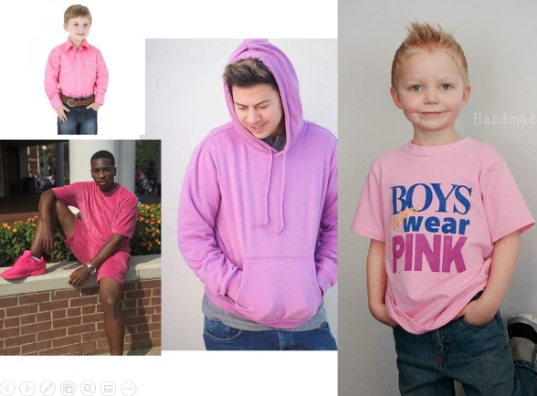
Y3 and Y4 (45 mins)
As above – talk about the fact that families may be different groups of people, but they share the same love and caring about each other.
Play Gender Game – are these things more for boys or girls eg mud, pink, football? Is it OK for everyone to like them? There are lots of ways to be a boy or a girl and they’re all fine. What can we do to make things fair for everyone?
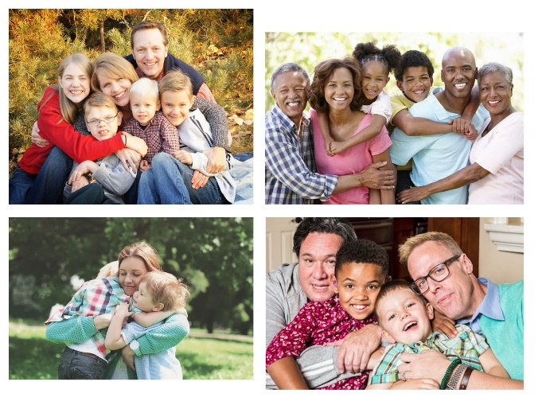
Read ‘Introducing Teddy’ about a Teddy who ‘just feels she’s a girl’, despite being in a boy’s body. Focus on being a good friend to someone who feels like this, as well as how Teddy feels. Explain that some children and adults also feel that their body doesn’t match how they feel inside. Ask how we would treat someone who felt like that and joined our school?

Y5 and Y6 (1 hour)
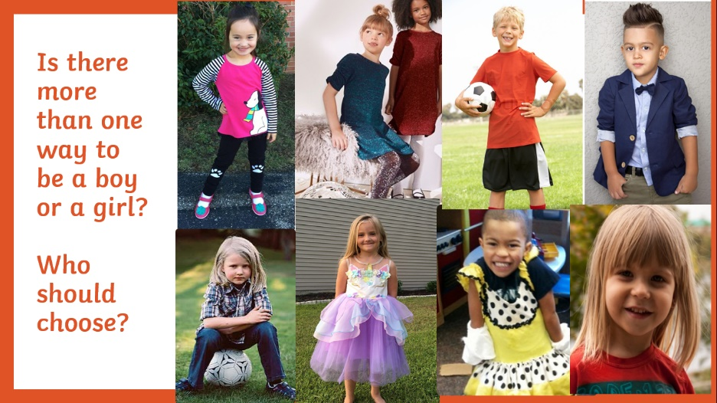
Sort the gendered magnetic words for boys and girls (currently available on Amazon) and have a deeper discussion about gender stereotyping and feeling pressured to behave in a particular way. Focus on whether children ever get picked on because they aren’t behaving like a ‘typical boy’ or ‘typical girl’. Discuss what we can do to ensure that everyone can be themselves and the importance of treating people fairly, even if they like different things from you.
Read ‘Introducing Teddy’ and introduce the concept of someone feeling that their body doesn’t match how they feel inside. (as Y3/4)
Use the Pop ‘n’ Olly children’s video to explain the meaning of LGBT (very basic– a man who loves a man; a woman who loves a woman, etc. ). Explain that lots of people live very happy lives as LGBT and that the law protects people and says we must treat LGBT people equally. Talk about how some people are bullied because they are LGBT. Explain that my son is gay but didn’t want to tell anyone at school because he heard things around him that made him feel unsafe. Discuss what he might have heard. Focus on the use of the word ‘gay’ to mean something is rubbish, wrong or unpleasant. Explain how it can be hurtful to use this word negatively to people who are gay or people who have gay friends and family. Ask children, if you don’t like the use of the word like this what could you do – emphasis on tell a teacher.
Opportunity to ask questions

Y7 (1 hour)
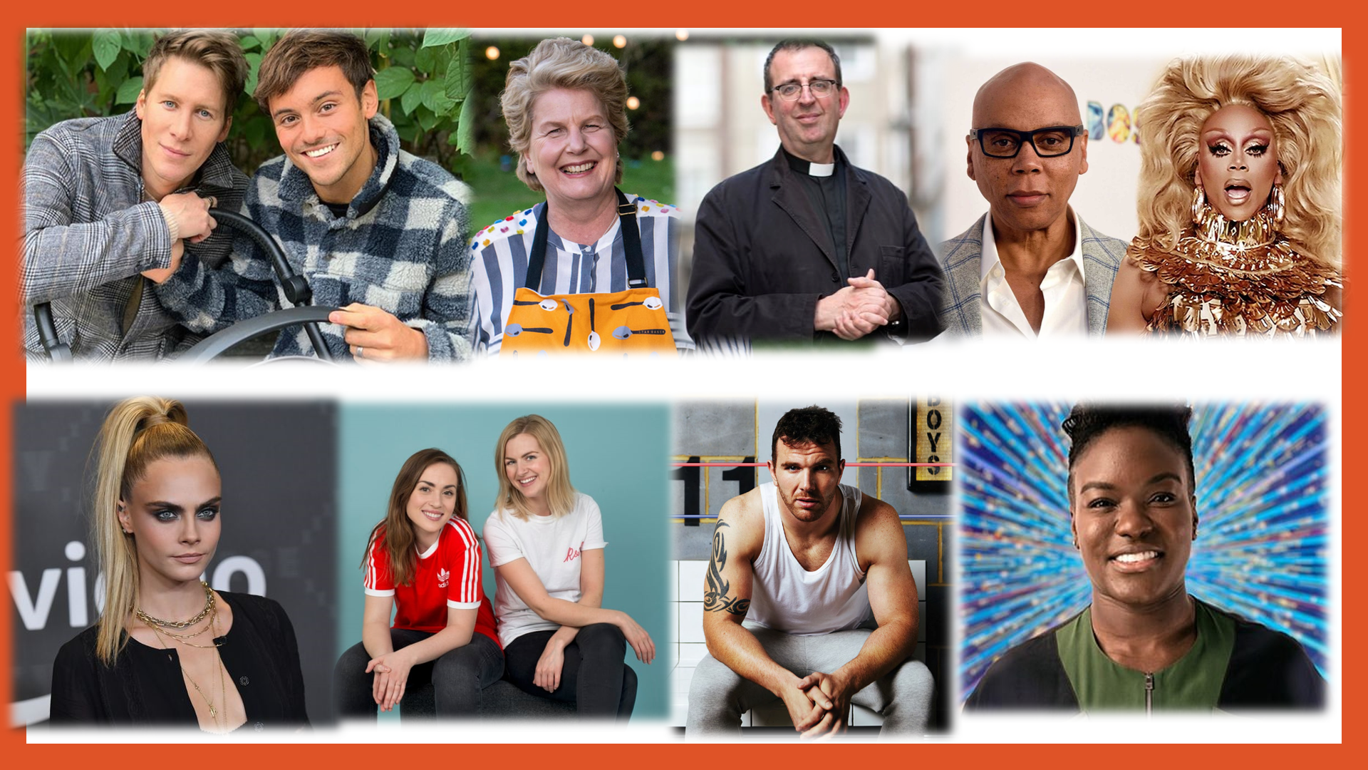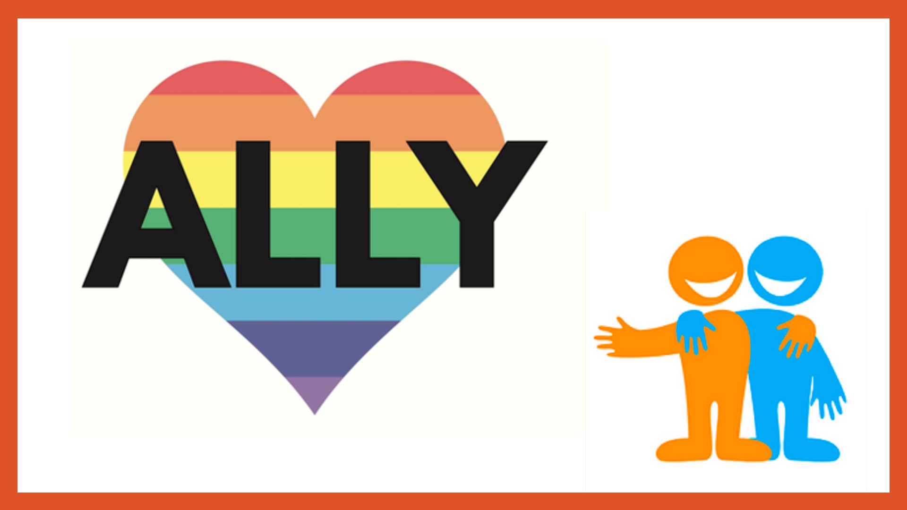

Discussion and explanation of key terms – LGBT, also including the difference between gender and sexuality. Discussion on how gender isn’t rigidly defined - people identify in different ways and like to express themselves in different ways – it is up to the individual how they wish to present themselves.
Information on being trans and the challenges faced by trans people because of how they are treated. Discussion on how trans people should be treated, including respect for names and pronouns. Clarification that being a girl who likes traditional ‘boy’ things and vice versa does not make you trans – there are many ways to be a boy or girl and we shouldn’t feel restricted to certain things because of our gender.
Discussion on the use of homophobic language and its impact on LBGT people (who may not yet know they are LGBT) and people with LGBT family and friends.
Advice on coming out and where to go to for advice and support
Discussion on being a good ally to LGBT people and sticking up for people who are being targeted. Discussion on what pupils could do if they witness LGBT bullying in school.
Opportunity to ask questions.

